ME341A – Heat and Mass Transfer

**EXPERIMENT 1**

**HEAT TRANSFER IN NATURAL CONVECTION**

**Date: 16 / 01 / 2018**



Department of Mechanical Engineering

Indian Institute of Technology Kanpur

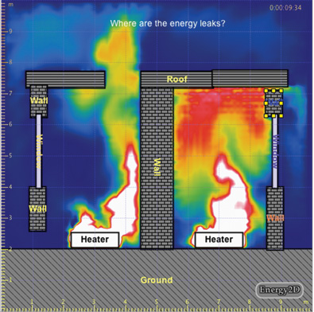

**Group – G1 (a)**

**Members:**

AVINASH KUMAR – 150169

ANUTOSH NIMESH – 150125

SHIKHAR SHIVRAJ JAISWAL – 150670

**OBJECTIVE:**

The purpose of this experiment is to study experimentally the natural convection pipe flows at different heating level.

**EXPERIMENTAL PROCEDURE:**

1. Switch on the supply and adjust the dimmerstat to obtain the required heat input (say 40W, 60 W, 70 W).

2. Monitor the temperature T1 to T8 every five minutes till steady state is reached.

3. Wait till the steady state is reached. This is confirmed from temperature readings (T1 toT7). If they remain steady and do not register a change of more than 1 0C per hour.

4. Measure the surface temperature at various points (T1 to T7).

5. Note the ambient temperature, T8.

6. Repeat the experiment for different heat inputs (say 40 W, 60 W, 70 W) by varying dimmerstat position.

**RESULTS AND DISCUSSION:**

Case 1:

Voltage = 37 V

Current = 0.84 A

Power = 31.08 W

Ambient temperature Tambient = T8

Surface temperature Tav = Ts = 𝑇1+𝑇2+𝑇3+𝑇4+𝑇5+𝑇6+𝑇7 / 7

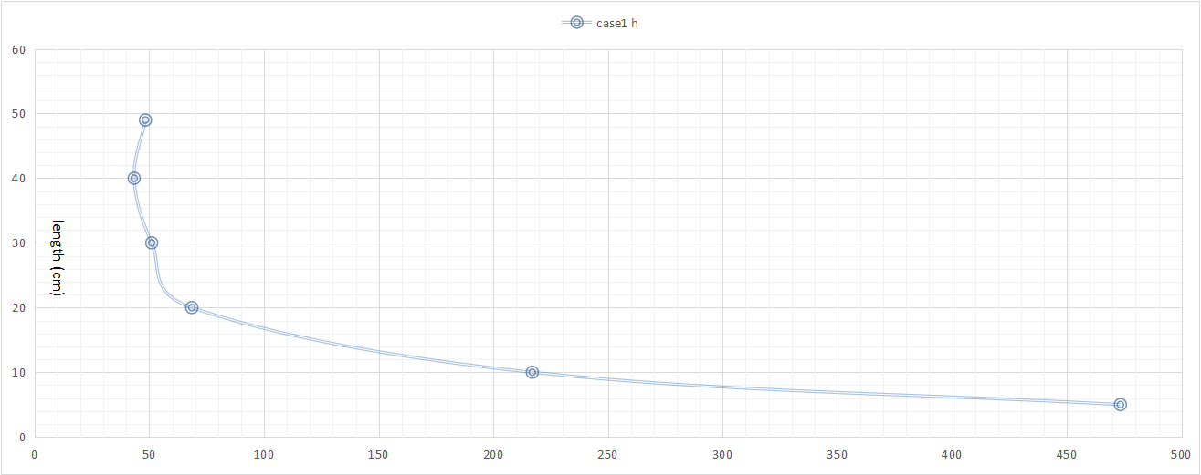

h (W/m2K)

|  |  |  |  |  |  |  |  |  |  |  |  |
| --- | --- | --- | --- | --- | --- | --- | --- | --- | --- | --- | --- |
|  | **Thermocouple temperature (oC)** | | | | | | | |  |  | **W/m2K** |
| **S No.** | **T1** | **T2** | **T3** | **T4** | **T5** | **T6** | **T7** | **T8** | **TIME(min)** | **Tav** | **hav exp** |
| 1 | 27 | 35 | 36 | 43 | 40 | 39 | 35 | 25 | 3:05 | 35.8 | 52.06879612 |
| 2 | 28 | 36 | 37 | 44 | 42 | 40 | 36 | 25 | 3:15 | 36.5 | 47.3352692 |
| 3 | 29 | 37 | 38 | 45 | 42 | 41 | 37 | 25 | 3:25 | 36.75 | 44.31386904 |

|  |  |  |  |  |  |
| --- | --- | --- | --- | --- | --- |
| **hav exp** | **grashoff no** | **prandtl no** | **gr.pr** | **h theo** | **% error = ( hexp – hth)/hth x 100** |
| 52.06879612 | 158087097.8 | 0.695769231 | 109992138.4 | 3.250683589 | 1501.779893 |
| 47.3352692 | 173609323.5 | 0.695769231 | 120792025.5 | 3.327697598 | 1322.463064 |
| 44.31386904 | 185217470.9 | 0.695769231 | 128868617.3 | 3.381980347 | 1210.293511 |

Case 2:

Voltage = 43 V

Current = 0.97 A

Power = 41.71 W

Ambient temperature Tambient = T8

Surface temperature Tav = Ts = 𝑇1+𝑇2+𝑇3+𝑇4+𝑇5+𝑇6+𝑇7 / 7

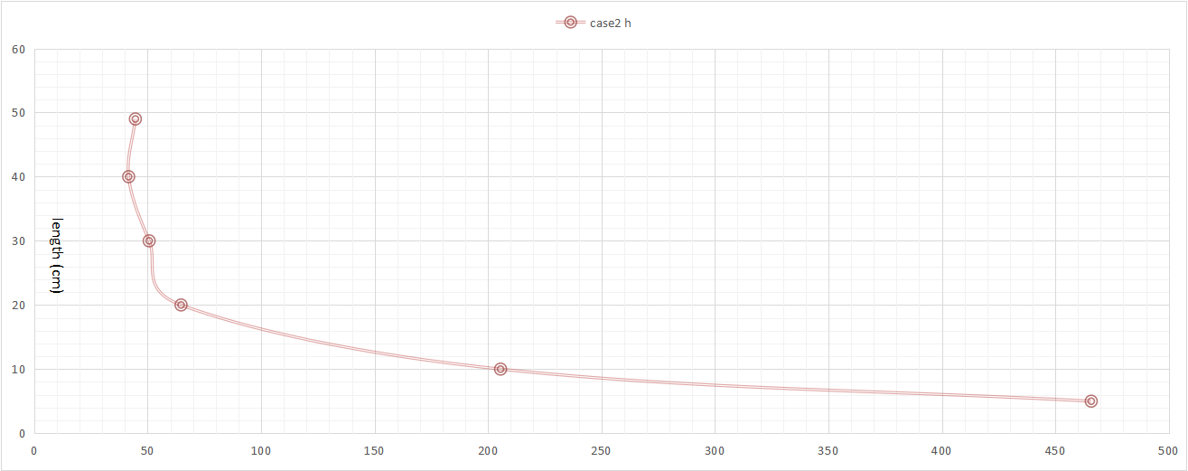

h (W/m2K)

|  |  |  |  |  |  |  |  |  |  |  |  |
| --- | --- | --- | --- | --- | --- | --- | --- | --- | --- | --- | --- |
| **S No.** | **T1** | **T2** | **T3** | **T4** | **T5** | **T6** | **T7** | **T8** | **TIME(min)** | **Tav** | **hav exp** |
| 1 | 29 | 37 | 38 | 46 | 43 | 41 | 38 | 25 | 0:00 | 37.125 | 57.63084255 |
| 2 | 29 | 39 | 40 | 49 | 45 | 43 | 39 | 26 | 0:10 | 38.75 | 54.80580125 |
| 3 | 30 | 40 | 41 | 51 | 47 | 45 | 42 | 26 | 0:20 | 40.25 | 49.03676954 |
| 4 | 31 | 41 | 43 | 53 | 49 | 47 | 42 | 26 | 0:30 | 41.5 | 45.08219135 |
| 5 | 31 | 43 | 44 | 53 | 50 | 48 | 43 | 26 | 0:40 | 42.25 | 43.00147483 |
| 6 | 32 | 43 | 45 | 54 | 51 | 48 | 44 | 26 | 0:50 | 42.875 | 41.40882761 |

|  |  |  |  |  |  |
| --- | --- | --- | --- | --- | --- |
| **hav exp** | **grashoff no** | **prandtl no** | **gr.pr** | **h theo** | **% error = ( hexp – hth)/hth x 100** |
| 57.63084255 | 191010807.4 | 0.695769231 | 132899442.6 | 3.408121564 | 1590.985532 |
| 54.80580125 | 199993444.3 | 0.695769231 | 139149284.9 | 3.447502041 | 1489.724983 |
| 49.03676954 | 222974460.2 | 0.695769231 | 155138768.7 | 3.542536816 | 1284.227521 |
| 45.08219135 | 242039463.6 | 0.695769231 | 168403611.4 | 3.615947676 | 1146.760058 |
| 43.00147483 | 253441220.2 | 0.695769231 | 176336602.9 | 3.657799572 | 1075.610472 |
| 41.40882761 | 262921436.6 | 0.695769231 | 182932645.7 | 3.691535857 | 1021.723565 |

Case 3:

Voltage = 50 V

Current = 1.11 A

Power = 55.5 W

Ambient temperature Tambient = T8

Surface temperature Tav = Ts = 𝑇1+𝑇2+𝑇3+𝑇4+𝑇5+𝑇6+𝑇7 / 7

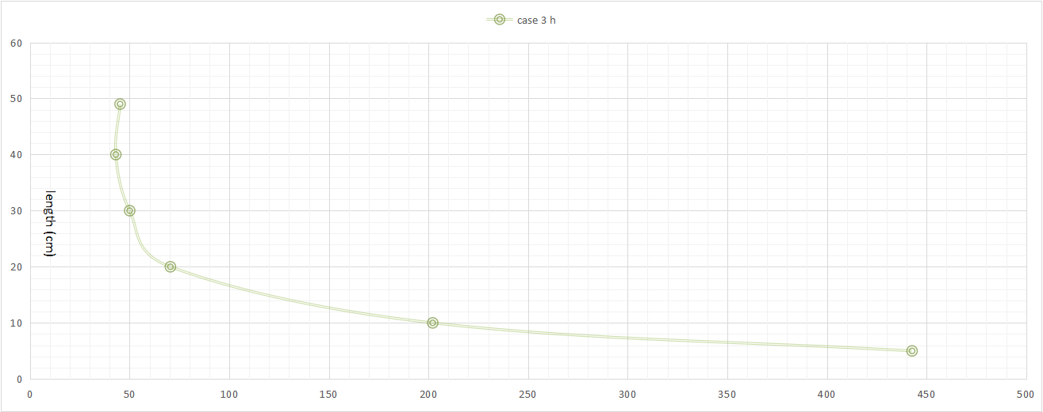

h (W/m2K)

|  |  |  |  |  |  |  |  |  |  |  |  |
| --- | --- | --- | --- | --- | --- | --- | --- | --- | --- | --- | --- |
| **S No.** | **T1** | **T2** | **T3** | **T4** | **T5** | **T6** | **T7** | **T8** | **TIME(min)** | **Tav** | **hav exp** |
| 1 | 32 | 43 | 45 | 54 | 51 | 49 | 44 | 26 | 0:00 | 43 | 54.69411357 |
| 2 | 32 | 45 | 47 | 57 | 54 | 51 | 45 | 26 | 0:10 | 44.625 | 49.92214393 |
| 3 | 32 | 46 | 48 | 58 | 55 | 52 | 46 | 26 | 0:20 | 45.375 | 47.98967384 |
| 4 | 32 | 47 | 49 | 59 | 57 | 53 | 47 | 26 | 0:30 | 46.25 | 45.91604596 |
| 5 | 32 | 48 | 50 | 58 | 58 | 54 | 48 | 26 | 0:40 | 46.75 | 44.80963521 |

|  |  |  |  |  |  |
| --- | --- | --- | --- | --- | --- |
| **hav exp** | **grashoff no** | **prandtl no** | **gr.pr** | **h theo** | **% error = ( hexp – hth)/hth x 100** |
| 54.69411357 | 264815167.7 | 0.695769231 | 184250245.5 | 3.698165188 | 1378.952691 |
| 49.92214393 | 289363803.1 | 0.695769231 | 201330430.7 | 3.781043231 | 1220.327245 |
| 47.98967384 | 300650356.2 | 0.695769231 | 209183267.1 | 3.817385528 | 1157.134588 |
| 45.91604596 | 313783391.9 | 0.695769231 | 218320829.2 | 3.858407387 | 1090.025867 |
| 44.80963521 | 321271306.8 | 0.695769231 | 223530690 | 3.881222827 | 1054.523644 |

**DISCUSSIONS AND CONCLUSIONS:**

➢ The heat transfer coefficient is maximum at the bottom as the boundary layers begins to form from the bottom and it decreases with the thickening of the boundary layer

➢ The little variations in the middle are due to the transition of the laminar boundary layer to turbulent ones.

➢ The theoretical value of ‘h’ is less than the experimental value. The possible reasons are-

1. We have neglected the heat loss through radiation while calculating hth.
2. We have used the average temperature of the air to calculate the hth which have lowered its value. A better approach would be to integrate the temperature along the length of the tube after choosing a temperature profile.

**APPENDIX:**

**Sample Calculation for Case 1 and serial no - 2**

Voltage reading, 𝑉=37 𝑉

Current reading, 𝐼=0.84 𝐴

Rate of heating, 𝑞=𝑉×𝐼=37×0.84=31.08 𝑊

Diameter = 0.038 m

Surface area Total, 𝐴=𝜋×𝑑×𝑙= 𝜋×0.038×0.5=0.0597 𝑚2

Surface Temperature, 𝑇𝑠=𝑇1+𝑇2+𝑇3+𝑇4+𝑇5+𝑇6+𝑇7/7 = 36.5 ℃

Ambient Temperature, 𝑇𝑎=25 ℃

*Experimental heat transfer coefficient:*

Average heat transfer coefficient, ℎ𝑎𝑣𝑔=𝑞/(𝑇𝑠−𝑇𝑎)=31.080/.0597×(36.5−25)=47.335 𝑊/m2K

|  |  |  |
| --- | --- | --- |
| **Lengths**  **(cm)** | **Surface area As= 𝜋×𝑑×𝑙 (m2)** | **h**  **(W/m2K)** |
| 0 | 0 | ∞ |
| 5 | 0.005969026 | 473.352692 |
| 10 | 0.011938052 | 216.9533172 |
| 20 | 0.023876104 | 68.51157384 |
| 30 | 0.035814156 | 51.04783933 |
| 40 | 0.047752208 | 43.39066343 |
| 49 | 0.058496455 | 48.3012951 |

For thermocouple 2, ℎ2=𝑞/(𝑇𝑠−𝑇𝑎)=31.080/0.0×(28−25)=473.35 𝑊/m2K

For thermocouple 3, ℎ3=𝑞/(𝑇𝑠−𝑇𝑎)=31.080/.00596×(36−25)=216.9533 𝑊/m2K

For thermocouple 4, ℎ4=𝑞/(𝑇𝑠−𝑇𝑎)=31.080/.02387×(44−25)=68.5115 𝑊/m2K

For thermocouple 5, ℎ5=𝑞/(𝑇𝑠−𝑇𝑎)=31.080/.035814×(42−25)=51.047 𝑊/m2K

For thermocouple 6, ℎ6=𝑞/(𝑇𝑠−𝑇𝑎)=31.080/.0477522×(40−25)=43.0478 𝑊/m2K

For thermocouple 7, ℎ7=𝑞/(𝑇𝑠−𝑇𝑎)=31.080/.058496×(36−25)=48.30129 𝑊/m2K

*Theoretical heat transfer coefficients:*

𝐿 = 0.5 m; 𝑘 = 0.0264 W/mK; 𝜈 = 16.0 x 10-6 m2/s; 𝜇 = 1.846 x 10-5 N.s/m2; 𝐶𝑝 = 1004.9 J/Kg.K; 𝑔 = 9.81 m/s2;

Δ𝑇 = 11.5°C; 𝑇𝑓 = 30.75°C

𝛽 = 1/(30.75+273) = 0.0033𝐾−1

Calculating Grashoff number,

𝐺𝑟 = 𝑔𝐿3𝛽Δ𝑇/𝜈2 = 9.81×0.53×0.0033×11.5/(16.04×10-6)2=17.36E+8

Calculating Prandlt Number,

𝑃𝑟 = 𝜇𝐶𝑝/𝑘 = (1.846 x 10-6)×1004.9/0.0264=0.695

𝐺𝑟×𝑃𝑟=1.207E+8

Hence we would be using,

𝑁𝑢=ℎ𝑡ℎ/𝐿𝑘=0.59(𝐺𝑟.𝑃𝑟)1/4 = 102.409

(ℎ𝑡ℎ)𝑎𝑣𝑔 = 3.327 𝑊/m2K

The same calculations are repeated for calculating ℎ𝑡ℎ for each thermocouple and results are tabulated above.

**PRECAUTIONS:**

1) To ensure natural convection, ceiling fan must be switched off.

2) Keep dimmerstat to zero volt positions and increase it slowly.

3) Operate the switch of temperature indicator gently from one position to other, i.e. from position 1 to 8 position.

4) Never exceed 80 W power.

**REFERENCES:**

1) Cengel, Y.A., Heat transfer a practical approach, McGraw Hill publication.

2) Heat and Mass Transfer lab manual

3) Sukhatme, Dr. S.P., A textbook of Heat Transfer, Universities Press

4) Holman, J.P., Heat transfer, McGraw Hill publication

5) Incropera, F.P., and Dewitt, D. P., Fundamentals of Heat and Mass Transfer, John Wiley & Sons, Inc.

6) https://www.engineeringtoolbox.com/air-properties-d_156.html

